09th June 2017

**YOKOHAMA Strengthening Overseas Sales of High-Pressure Hoses**

The Yokohama Rubber Co., Ltd., today announced that two of its high-pressure hoses sold overseas – the SAE100R1S and the SAE100R2S – have been certified by DNV GL, a maritime classification and certification society based in Norway and Germany.

High-pressure hoses are used in a wide variety of hydraulic equipment found in construction machinery, industrial machinery, marine vessels and port facilities. High-pressure hoses used on ships and in port facilities must be certified by national or international classification and certification societies. Compliant with the United States’ SAE standard and Europe’s EN standard, YOKOHAMA’s SAE100R1S and SAE100R2S hoses have to date been sold overseas for use primarily in construction and industrial machinery. Receiving DNV GL certification is a first step toward expanding the markets for these products. To further strengthen overseas sales of its high-pressure hoses, YOKOHAMA also plans to seek DNV GL certification of its Versatran high-pressure hose, which it began marketing overseas earlier this year.

YOKOHAMA is also strengthening its Japan sales of high-pressure hoses used on ships and in port facilities. The Company’s core domestic market products – the LEVEX (NWP) and OMNIBAR (OMB) – have been certified by DNV GL, Japan’s classification society ClassNK (Nippon Kaiji Kyokai), and the US’s American Bureau of Shipping (ABS). In addition, YOKOHAMA has been selling its RS210 and RS280 high-pressure hoses designed specifically for use on ships and in port facilities since August 2014 and July 2016, respectively.

Note: “Classification” here refers to the assigning of a qualification and grade to ships and related fittings and installations, as well as to the manufacturers of such equipment, after examination by a classification society to determine compliance with certain standards and regulations. Such classifications are international standards used for marketing and for obtaining insurance.

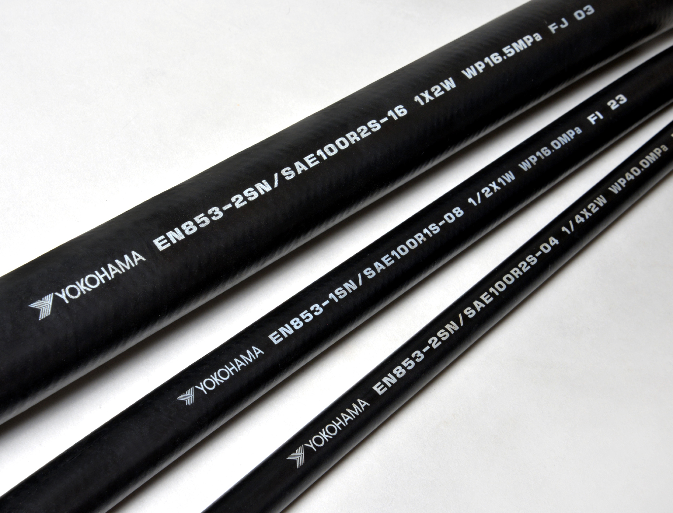

*High-pressure hoses sold overseas_SAE100R1S and SAE100R2S*